Chapter 3.O-O Programming and C++

3.1 Software crisis

SW 개발과유지보수문제

개발 비용 증가

개발 시간 증가

SW 품질이 떨어짐

소프트웨어개발주기

유지보수 문제가 가장크다

코드 재사용에 의한 문제 해결:function의 상속과 추가 코딩 방법을 실습

SW복잡도증가, 크기도 증가

단순 coding이아닌 SW 설계능력필요

유지보수비용의증가

새로운 SW 개발방법

기존 SW의재사용

새로운 기능 추가 확장이 용이

프로그램기능이 추가되고 확장되는 요건변화

-함수중심의 설계방법은 비효율적

-객체지향방법: 재사용

소프트웨어 위기에 대한 해결

-기존 소프트웨어의 재사용

-소프트웨어 component

-A new way of thinking and designing

C++ programming

3.2 O-O design and Abstraction

3.2.1 프로그램의설계방법론

SW 개발

requirement analysis

design

coding

testing

maintenance

program 개발과정

1) 문제정의

2) 문제에서 요구하는 기능 명세 작성

3) 자료구조 설계 및 algorithm 작성

4) programming language로구현

5) testing & debugging

software specification

program의 input, output, functions을명확하게기술

Software architecture 설계

architectural design

Class 간의 relationship

Subprogram들간의 호출 관계

detailed design

module design

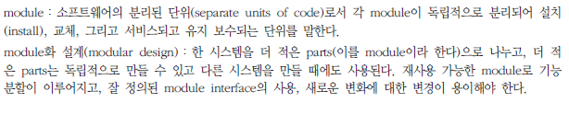

the specification of algorithms

Algorithm

English-like instructions that accomplish a particular task

For (int I = 0; I <n; i++) {

Examine a[i] and a[n-1] and suppose the smallest integer = a[j];

Interchange a[i] and a[j];

}

multiply.cpp//prototype declarationint multiply (int n1, int n2);//formal parameter listvoid main () { inti, j, k; k = multiply(i, j);//function argument라고부름}//function definitionint multiply(int n1, int n2){ // function formal parameter라고부름 // 이부분을함수body라고한다. return (n1 * n2);}

- algorithm 설계가 먼저? 자료구조 설계가 먼저인가?

1) abstract data type을 먼저설계

2) design of object representation

3) member function에 대한 algorithm을 설계

algorithmic decomposition versus object-oriented decomposition

the philosophy of divide-and-conquer: to break up a complex software design project into a number of simpler subprojects, and then tackle these subprojects individually

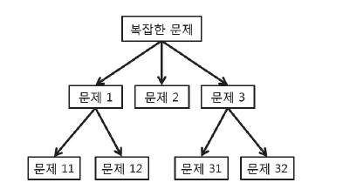

structured Top-Down Design

functional Decomposition

focus on operations (neglect data structure)

suitable well understood problem and stable requirement

problem with Top-Down Approach

Don't allow for evolutionary changes

Have single top level function, - not always true

Ignore important characteristics of the data

Hampers reusability

3.2.2 연산추상화

structured programming

goto statement

sum = 0; I = 0;

Loop : sum = sum + a[i]; I = I + 1;

If (I < n) goto loop;

multiply.cpp//prototype declarationint multiply (int n1, int n2);//formal parameter listvoid main () { inti, j, k; k = multiply(i, j);//function argument라고부름}//function definitionint multiply(int n1, int n2){ // function formal parameter라고부름 // 이부분을함수body라고한다. return (n1 * n2);}

block structure

Sum = 0;

For (int I = 0; I <n; i++) {

Sum = sum + a[i];

}
multiply.cpp//prototype declarationint multiply (int n1, int n2);//formal parameter listvoid main () { inti, j, k; k = multiply(i, j);//function argument라고부름}//function definitionint multiply(int n1, int n2){ // function formal parameter라고부름 // 이부분을함수body라고한다. return (n1 * n2);}

C programs: blocks

Main ( ) {

Int x;

Function1( );

Function2( );

…

}

Function1( ) {

Int x;

…

}

Function2( ) {

Int x;

…

}
y.cpp//prototype declarationint multiply (int n1, int n2);//formal parameter listvoid main () { inti, j, k; k = multiply(i, j);//function argument라고부름}//function definitionint multiply(int n1, int n2){ // function formal parameter라고부름 // 이부분을함수body라고한다. return (n1 * n2);}

Code reuse: call the subprogram

Subprograms become black boxes

Subprogram make up a powerful tool for abstraction

The most widespread mechanism for code reuse

3.2.3 데이터추상화

Data abstraction

User defined data type
struct Student
{
char name[20];
char snum[10];
char dept[10];
int age;
}

multiply.cpp//prototype declarationint multiply (int n1, int n2);//formal parameter listvoid main () { inti, j, k; k = multiply(i, j);//function argument라고부름}//function definitionint multiply(int n1, int n2){ // function formal parameter라고부름 // 이부분을함수body라고한다. return (n1 * n2);}

O-O programming

//*** file: stack.h

Class stack {

Public:

Void push (int n) {

A[++top] = n;

}

Int pop() {

Return a[top--];

}

Private:

Int top;

Inta[MaxStack];

};

multiply.cpp//prototype declarationint multiply (int n1, int n2);//formal parameter listvoid main () { inti, j, k; k = multiply(i, j);//function argument라고부름}//function definitionint multiply(int n1, int n2){ // function formal parameter라고부름 // 이부분을함수body라고한다. return (n1 * n2);}

#include stack.h

Int main ( ) {

Stack s1;

S1.push(9);

S1.pop();

Return 0;

};

multiply.cpp//prototype declarationint multiply (int n1, int n2);//formal parameter listvoid main () { inti, j, k; k = multiply(i, j);//function argument라고부름}//function definitionint multiply(int n1, int n2){ // function formal parameter라고부름 // 이부분을함수body라고한다. return (n1 * n2);}

3.2.4 추상데이터타입

Abstraction and data

Built-in data types: int, real, boolean

User-defined data types: struct, record

Abstract data type: class 사용

Public type and public behaviors

Hide private type representation and private member of functions

abstract data type

class Stack {

// objects: ordered list with zero or more elements

public:

Stack ( );

Boolean IsFull();

void Add(int item);

Boolean IsEmpty();

int *Delete(int&);

};

multiply.cpp//prototype declarationint multiply (int n1, int n2);//formal parameter listvoid main () { inti, j, k; k = multiply(i, j);//function argument라고부름}//function definitionint multiply(int n1, int n2){ // function formal parameter라고부름 // 이부분을함수body라고한다. return (n1 * n2);}

3.2.5 Object-Oriented Design

O-O design

O-O decomposition views software as a set of well-defined objects that model entities in applications. These objects interact with each other to form a software

자료구조와 알고리즘의 통합

Information hiding으로 문제의 복잡성을 해결함

모듈간의 종속성을 줄임

Global operation, global data를피함

Design choices를 local로 함

연속적인 개량, 응용의 확장 및 변경에 용이

객체 지향 설계 과정:

1)Definition of the problem domain

Describe a model of the reality that is being considered

2)Identification of the classes of objects

Recognize actors, agents, and servers of our model of reality

Make an identification by qualifying the nouns of the problems informal description

3)Analysis of objects

Characterize the behavior of an object

Establish the semantics of the objects and of the operations that you can perform

4)Formal description

Describe the services offered by a class by specifying an abstract data type

정식 표기 방법을 사용하여 명세를 기술

Formal specification

객체 자신과 각 객체의 clients 간의 약정(contract: interfaces)를 기술

추상 데이터 타입을 기술

5)Writing the object representation and implementing the body of functions

3.3 객체 지향 언어의 중요개념들

Three fundamental elements in any truly object-oriented language

Polymorphism

Inheritance

Classes

3.3.1 Class and object

Class와 object

Object

Describe a single element have a peculiar state of its own and other behaviors

Class

Describe a family of similar elements like a scheme that is used to define corresponding objects can define a number of objects

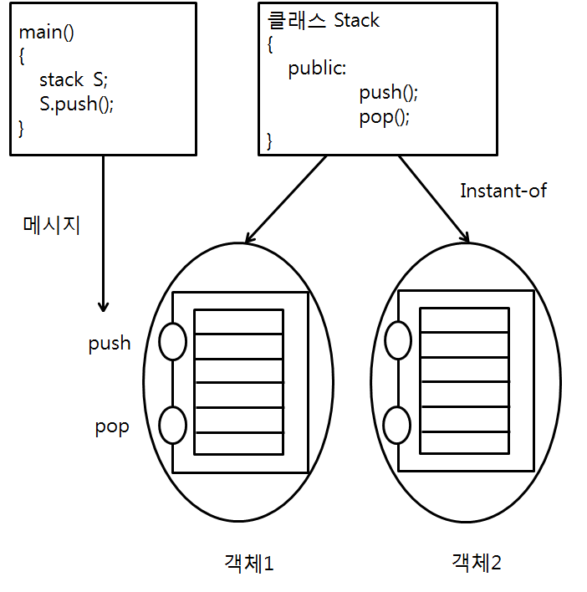

Object: Data + Method

method와 message

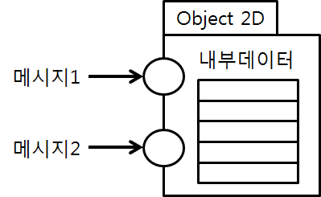

Encapsulation

An object

Has states

Has well-defined behaviors

Has a unique identifier(cf. key in relational model)

Represents some entity in the real world

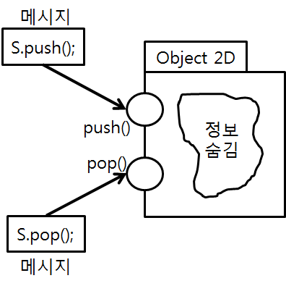

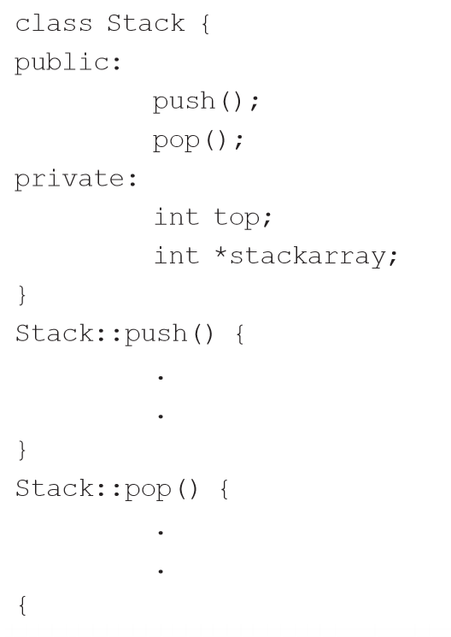

Encapsulation

정보 숨김 대상

Information hiding of Object

Users have only to use Public Interface

Permit users to ignore details of the systems

An Example: Stack

Internal Aspect: Implementation

External Aspect: Message Protocol

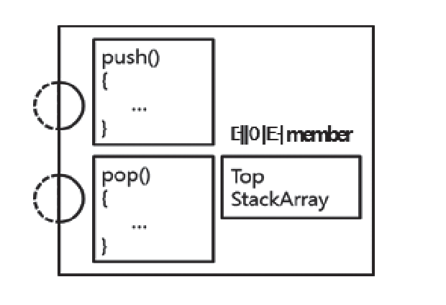

The most important concepts of good subdivision into modules: encapsulation(the principle of information hiding)

Class의주요특징

“hiding” both data as well as algorithms

Class는 block box와 같이 생각

Allowed to know what classes do, but not how they do it

클래스는 해당 클래스를 사용하는 다른 클래스 또는 프로그램에 영향을 주지 않고 구현을 변경하는 것이 가능

3.3.2 Inheritance: Class Hierarchy

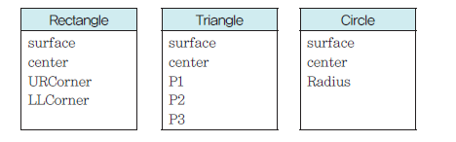

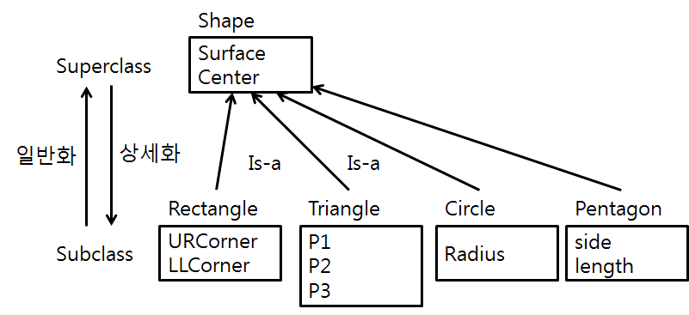

Possible to define a class, not from scratch, but in terms of another class

Define a new class on the top of existing classes rather than rewriting the classes

Use inheritance to manage similarities and differences between classes of similar objects

Consider inheritance as a specialization

Represent a subset that has some specific behavior of its own

Represent a generalization

Useful to “factor out” common elements
managers
secretaries
White collars

Inheritance eliminates the redundancy

Base class(Super) and Derived Class(Sub)

3.3.3 Polymorphism

Indicate, literally, the possibility that an entity takes many forms

The same message results in different actions when it is received by different objects

Perform the same operation in different ways

Example
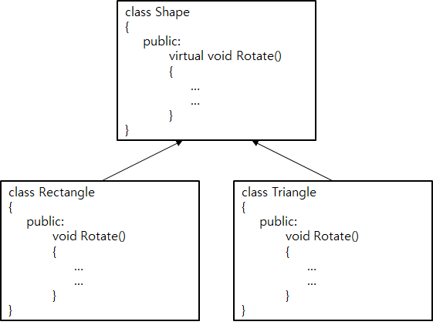

Actions invoked by rotate are different

같은 function에 대한 다른 responses를줌

Polymorphism and Dynamic Binding

Example

Int p, p0;

Shape x;

Rectangle r;

Circle c;

…

If p = p0, then x = r /*r is rectangle*/

Else x = c; /*c is circle*/

x.Rotate(p,30) /*send message to x*/
shape
rectangle
circle
x
r
c

Problem

Can't bind the message and method of object when compiling

Static Binding

Binding when compiling

Dynamic Binding(Late Binding)

Binding during Run-Time

What is BINDING

The connection between a function call and the actual code

In order to support polymorphism

Dynamic Binding

C++: "virtual" method 이용

Example

Polymorphism and Dynamic Binding 실습

static binding, dynamic binding을 실습

virtual 사용시, 미사용시 차이점을 실습

superclass, subclass에 같은 이름의 attributes, methods가 있을 때 문제점, 차이점 파악

superclass, subclass에 method 이름은 같은데 구현 body가 다른 것이 필요한 이유를 느끼는 실습

Static binding

-Function(C의 function)

Normal function

같은 이름을 가진 function이 두개 이상 존재할 수 없다(이름이 같으면 body도같다.)

Dynamic binding

-method:

Class내에 존재하는 Function

같은 이름을 가진 method가 여러 개 존재 가능 (이름이 같지만 body가 다른 method가 존재)

-Polymorphism, Operator Overloading 지원

3.4 C++ Languages

C++: C 언어의 확장

C 언어와의 호환성 유지: flexibility, efficiency, portability

Characterized by the addition to C of object-oriented constructs

3.4.1 Some history

C with classes, 1980

C was augmented with classes, strict type checking and type conversion in the parameters of function

C++ 1983, 84

The addition of virtual functions and operator overloading

The 2nd release of C++

Multiple inheritance, abstract classes

The release 2.1 of C++

Template construct and exception handling

The name of the language

In C, the operator ++ indicates increment

C++ is something more than C

3.4.2 General Features

C++ is C extended with classes, in-line functions, operator overloading, function name overloading, constant types, references, free store management operators, function argument checking

Does not always concern object-oriented programming

Static type checking on function arguments

C++ provides greater type safety

Compensate for Cs weakness without compromising Cs strengths

In-line function expansion

Substitute the function call with the function body itself

Provide a high degree of efficiency

Overloading operators

Make it possible to use the same name for different operations

Increase code readability

3.4.3 Constructs for Object-Oriented Programming

The type construct class

Can be instanced and are known as objects

Hide the internal implementation and support data structures

Inheritance relationships between classes

The possibility of defining a class using other classes as a foundation

Dynamic binding

Strongly related to polymorphism

The possibility that one entity refers to(at run time) objects of different classes

Limited within the inheritance hierarchy of a class

The structure of a class

The interface exported to the outside of the module

The implementation details are hidden

Use the technique of separate compilation

Three parts of the interface of a class

Private data structures

Represent the objects of a class and the possible private operations

Protected data and functions

Visible to the class’s subclasses

Public functions

Declared for “external” usage

Correspond to the operations provided by the abstraction being modeled by the class

Possible to declare (static) class variables

The friend construct

Complement the constructs for data-hiding

Allow you to freely access the private data of a class

Genericity and exception handling

Do not refer directly to object-oriented programming

Favor robust programming

